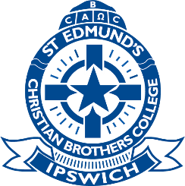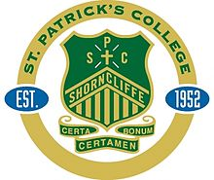

AIC SWIM MEET
Hosted by: St Edmund’s College and St Patrick’s College
Friday 12th February 2021
Venue: Centenary Aquatic Centre and Health Club (400 Gregory Terrace, Spring Hill)
Time: Warm Up (4:00pm) & Program Commences (4:15pm)
Colleges Attending:
Lane Allocation
1 | ASH
2 | ASH
3 | PAD
4 | SPC
5 | SEC
6 | VILLA
7 | SPLC
8 | SPLC

Officials: Each College is responsible for timing and recording the performances of its own swimmers.
Program:
Time (Approx.) | Event
4:15pm | 50m Freestyle (Year 5 – Open)
 | 100m Freestyle (Max. 2 swimmers per school per age group)
4:45pm | 50m Breaststroke (Year 5 – Open)
 | 100m Breaststroke (2 races only)
5:15pm | 50m Backstroke (Year 5 – Open)
 | 100m Backstroke (2 races only)
5:45pm | 50m Butterfly (Year 5 – Open)
 | 100m Butterfly (2 races only)
6:00pm | 4 x 50m Open Medley Relay

DUE TO COVID RESTRICTIONS – NO SPECTATORS WILL BE ALLOWED AT THIS MEET

