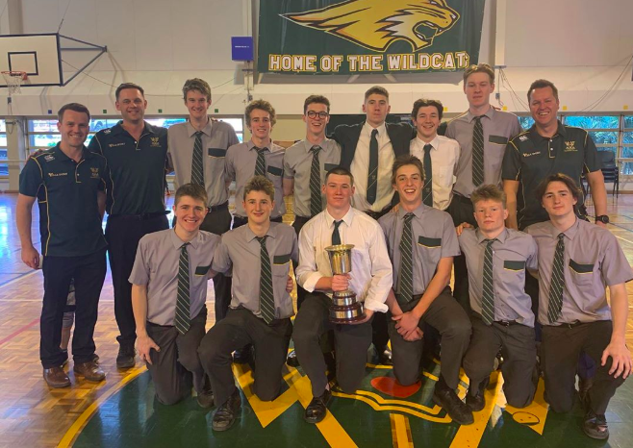

AIC Basketball Season Wrap

With Goold Hall packed to the rafters for the final game of the season, Villanova College produced a basketball masterclass to secure the school’s first undefeated First V premiership.

Villanova surged to a 63-33 over a strong St Laurence’s College First V, ending an outstanding season. The school celebrated its fifth successive AIC basketball aggregate trophy.

The AIC basketball season was a resounding success with the skills, sportsmanship and participation rates a credit to the schools and their coaching teams.

Villanova will have many of the First V squad members back for the 2020 season, including Queensland star Will Mahoney who consistently stood out for the green and gold. Villanova also celebrated a win in the 11A competition in a positive sign for the school.

Villanova’s efforts are underlined by the depth of this year’s First V competition, which produced thrilling matches week after week. St Edmund’s College finished in second place after closing the season with a 70-56 win over Padua College at home.

St Edmund’s didn’t lose a match after their opening round loss to Villanova, but the depth of the teams was shown when the Ipswich school had to go to overtime to beat St Patrick’s College.

St Edmund’s will head into the Molten Champion Basketball School of Queensland competition this week, hoping to improve on their 14th placing from last year.

At Shorncliffe, St Patrick’s sealed third place with a 55-50 win over a resilient St Peter’s Lutheran College. The result was a fitting end for both teams with St Patrick’s again showing the spirit that enabled them a huge win over Marist College Ashgrove while St Peter’s showed their fighting nature.

St Patrick’s will also welcome back most of their First V for next season.

Iona College tied St Patrick’s for third place with a strong 69-56 home win over Marist Ashgrove. Iona’s offence was strong, helping them to a cherished win over the team that had been the First V powerhouse in recent seasons. Marist Ashgrove continued to play excellent basketball across the season and presented a challenge for each of their rivals.

